**DAY-7 TestNG**

**QUESTION 1:**

//ClassEx1 Day7

**package** com.Test.Testing;

**import** org.junit.Test;

**import** org.openqa.selenium.WebDriver;

**import** org.openqa.selenium.chrome.ChromeDriver;

**import** org.openqa.selenium.chrome.ChromeOptions;

**import** org.testng.Assert;

**import** io.github.bonigarcia.wdm.WebDriverManager;

**public** **class** AppTest

{

@Test

**public** **void** shouldAnswerWithTrue()

{

ChromeOptions co=**new** ChromeOptions();

co.addArguments("--remote-allow-origins=*");

WebDriverManager.*chromedriver*().setup();

WebDriver driver=**new** ChromeDriver(co);

driver.get("https://demo.wpeverest.com/user-registration/guest-registration-form/");

driver.manage().window().maximize();

String actual=driver.getTitle();

String exp="Guest Registration Form – User Registration";

Assert.*assertEquals*(exp, actual);

}

}

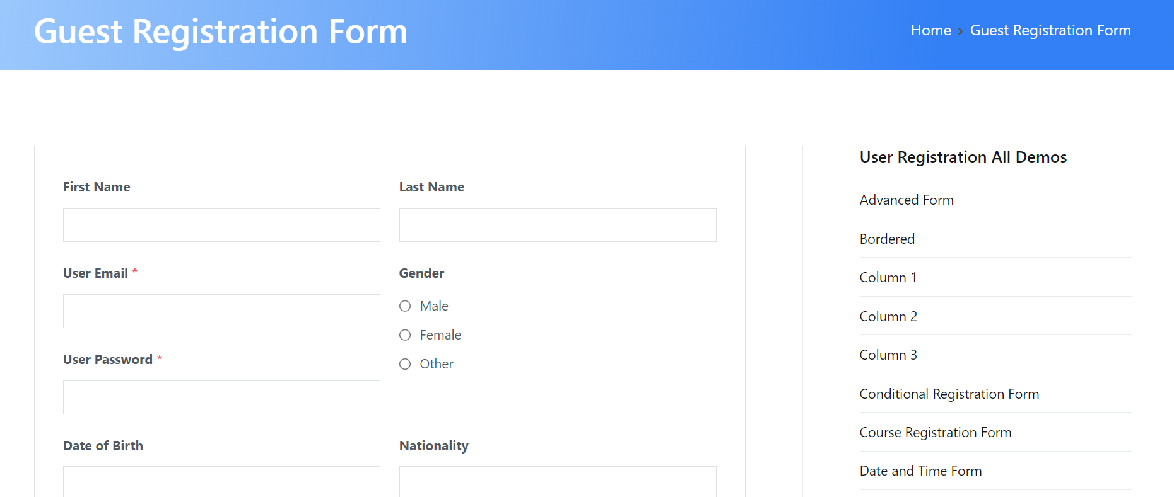

**QUESTION 2:**

//ClassEx1 Day7

**package** com.Test.Testing;

**import** org.testng.Assert;

**import** org.testng.annotations.Test;

**public** **class** Calculator {

@Test(priority=1)

**public** **void** Div() {

**int** n1=10;

**int** n2=30;

**int** res=n2/n1;

Assert.*assertEquals*(res,3);

}

@Test(priority=2)

**public** **void** Mul() {

**int** n1=20;

**int** n2=30;

**int** res=n1*n2;

Assert.*assertEquals*(res, 600);

}

@Test(priority=3)

**public** **void** Sub() {

**int** n1=50;

**int** n2=20;

**int** res=n1-n2;

Assert.*assertEquals*(res,30);

}

@Test(priority=4)

**public** **void** Add() {

**int** n1=300;

**int** n2=215;

**int** res=n1+n2;

Assert.*assertEquals*(res, 400);

}

}

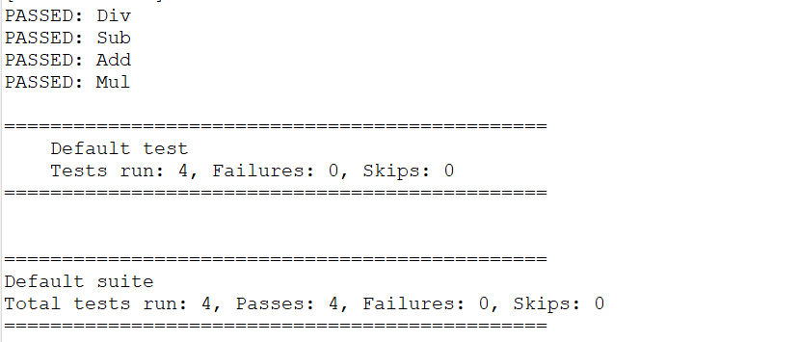

**QUESTION 3:**

package com.Test.Testing;

import org.testng.annotations.Test;

import io.github.bonigarcia.wdm.WebDriverManager;

import org.testng.annotations.BeforeMethod;

import org.openqa.selenium.By;

import org.openqa.selenium.WebDriver;

import org.openqa.selenium.chrome.ChromeDriver;

import org.openqa.selenium.chrome.ChromeOptions;

import org.testng.Assert;

import org.testng.annotations.AfterMethod;

public class CE3 {

WebDriver driver;

@Test

public void print() throws InterruptedException {

driver.get("https://opensource-demo.orangehrmlive.com/web/index.php/auth/login");

Thread.sleep(3000);

driver.findElement(By.xpath("//input[@name='username']")).sendKeys("Admin");

driver.findElement(By.xpath("//input[@name='password']")).sendKeys("admin123");

driver.findElement(By.xpath("//*[@id=\"app\"]/div[1]/div/div[1]/div/div[2]/div[2]/form/div[3]/button")).click();

Thread.sleep(3000);

String text=driver.findElement(By.xpath("//h6[@class=\'oxd-text oxd-text--h6 oxd-topbar-header-breadcrumb-module\']")).getText();

String expText="Dashboard";

Assert.assertEquals(text, expText);

}

@BeforeMethod

public void beforeMethod() {

ChromeOptions co=new ChromeOptions();

co.addArguments("--remote-allow-origins=*");

WebDriverManager.chromedriver().setup();

driver=new ChromeDriver(co);

}

@AfterMethod

public void afterMethod() {

driver.close();

}

}

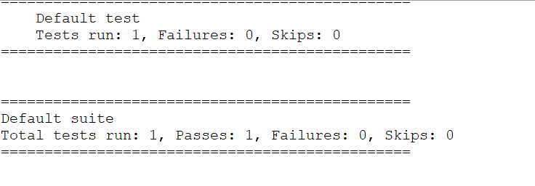

**QUESTION 4:**

**package** com.Test.Testing;

**import** org.testng.annotations.Test;

**import** io.github.bonigarcia.wdm.WebDriverManager;

**import** org.testng.annotations.BeforeMethod;

**import** org.openqa.selenium.By;

**import** org.openqa.selenium.WebDriver;

**import** org.openqa.selenium.chrome.ChromeDriver;

**import** org.openqa.selenium.chrome.ChromeOptions;

**import** org.testng.annotations.AfterMethod;

**public** **class** CE4 {

WebDriver driver;

@Test

**public** **void** login() **throws** InterruptedException {

ChromeOptions co=**new** ChromeOptions();

co.addArguments("--remote-allow-origins=*");

WebDriverManager.*chromedriver*().setup();

driver=**new** ChromeDriver(co);

driver.get("https://opensource-demo.orangehrmlive.com/web/index.php/auth/login");

driver.manage().window().maximize();

Thread.*sleep*(3000);

driver.findElement(By.*xpath*("//input[@name='username']")).sendKeys("Admin");

driver.findElement(By.*xpath*("//input[@name='password']")).sendKeys("admin123");

driver.findElement(By.*xpath*("//*[@id=\"app\"]/div[1]/div/div[1]/div/div[2]/div[2]/form/div[3]/button")).click();

Thread.*sleep*(3000);

}

@Test(dependsOnMethods=("login"))

**public** **void** logout() **throws** InterruptedException { driver.findElement(By.*xpath*("//*[@id=\"app\"]/div[1]/div[1]/header/div[1]/div[2]/ul/li/span")).click();

driver.findElement(By.*xpath*("//*[@id=\"app\"]/div[1]/div[1]/header/div[1]/div[2]/ul/li/ul/li[4]/a")).click();

}

}

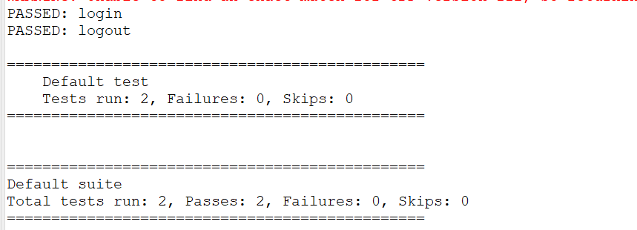

**QUESTION 5:**

package com.Test.Testing;

import org.testng.annotations.Test;

import io.github.bonigarcia.wdm.WebDriverManager;

import org.testng.annotations.BeforeMethod;

import java.util.concurrent.TimeUnit;

import org.openqa.selenium.By;

import org.openqa.selenium.WebDriver;

import org.openqa.selenium.chrome.ChromeDriver;

import org.openqa.selenium.chrome.ChromeOptions;

import org.testng.Assert;

import org.testng.annotations.AfterMethod;

public class d75

{

WebDriver d;

@Test(groups="Smoke Test")

public void t1()

{

String eurl="https://www.godaddy.com/en-in";

String curl=d.getCurrentUrl();

Assert.assertEquals(eurl,curl);

String etitle="Domain Names, Websites, Hosting & Online Marketing Tools - GoDaddy IN";

String ctitle=d.getTitle();

Assert.assertEquals(etitle,ctitle);

}

@Test(groups="Regression Test")

public void t2()

{

d.manage().timeouts().implicitlyWait(10,TimeUnit.SECONDS);

d.findElement(By.xpath("//*[@id=\"id-631b049a-e9c0-4d24-8710-c504745206dd\"]/div[2]/div[1]/ul/li[1]/button")).click();

d.findElement(By.xpath("//*[@id=\"id-631b049a-e9c0-4d24-8710-c504745206dd\"]/div[2]/div[1]/ul/li[1]/div/div[2]/div[1]/ul/li[2]/a")).click();

}

@Test(groups="Regression Test")

public void t3()

{

d.manage().timeouts().implicitlyWait(10,TimeUnit.SECONDS);

d.findElement(By.xpath("//*[@id=\"id-631b049a-e9c0-4d24-8710-c504745206dd\"]/div[2]/div[1]/ul/li[1]/button")).click();

d.findElement(By.xpath("//*[@id=\"id-631b049a-e9c0-4d24-8710-c504745206dd\"]/div[2]/div[1]/ul/li[1]/div/div[2]/div[1]/ul/li[2]/a")).click();

String ctitle=d.getTitle();

String etitle="GoDaddy Domain Search - Buy and Register Available Domain Names";

System.out.println(ctitle);

Assert.assertEquals(etitle, ctitle);

}

@BeforeMethod

public void beforeMethod()

{

ChromeOptions co=new ChromeOptions();

co.addArguments("--remote-allow-origins=*");

WebDriverManager.chromedriver().setup();

d=new ChromeDriver(co);

d.get("https://www.godaddy.com/en-in");

d.manage().window().maximize();

}

@AfterMethod

public void afterMethod()

{

d.close();

}

}

